MODULE 7 29TH & 30TH August READING THE STARS
@ Uluru with Bill Harney Elder Talking on Star Knowledge
Christo Miliotis Planting by the Moon and Stars .

MODULE 8 28TH September
Rob Greatholder Potting Mixes @ Warrah Farm
29TH September Dr Christo Miliotis Fermenting foods for a healthy Gut Microbiome

MODULE 9 24th & 25th October
Dr Christo Miliotis Carbonomics for reversing climate change .Cultivating a Sense of Humus.

MODULE 10 28TH & 29TH November
Weed and Pest Control without chemicals Christo Miliots
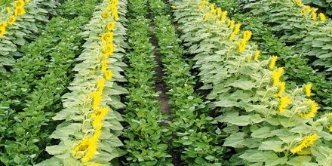
OUTLINE OF REGENERATIVE AGRICULTURE COURSE IN 2020 .
The course will be held on 5 acres of land being developed as an organic garden around the school garden concept as a platform for experiential learning .
It will be offered to teachers to teach the compulsory unit in Agriculture and Food in the Junior High School years, but it is also open to Farmers and Gardeners.
YOU WILL LEARN
- INTEGRATING THE SOLAR CYCLE, THE CARBON CYCLE, THE WATER CYCLE AND THE NUTRIENT CYCLE WITH DEVELPING THE SOIL CARBON SPONGE
C02 correlates with rising global temperatures however the major driver for climate change is the increased heat that is trapped by the increased C02 produces more water vapour and water vapour makes up 95% of greenhouse gases
The point of agency to cool the planet is to build the soil carbon sponge.
A 1% increase in soil carbon will increase the water holding capacity of the soil by 144,000 litres per hectare.
That will support more vegetation and just as we sweat when we have a fever to cool our body to the earths fever can be reduced by having more vegetative growth as in trees , cover crops grasslands which through transpiration cools the surface of the earth.
Furthermore, when the bacteria from the leaves of trees and the soil fungal spores ascend high into the atmosphere the heat trapping water vapour forms clouds which reradiates incoming solar radiation and so cools down the atmosphere.
- Plants drawdown CO2 and when the plant dies and is decomposed by soil microbes this increased soil carbon builds the soil carbon sponge to restore the degraded soils, rehydrate the land and increase productivity.
- A 2% increase in soil carbon on all agricultural lands will drawdown all of our annual global co2 emissions
‘The most restorative thing we can do for the planet is to grow humus’
- Humus is the ideal plant food it is stable carbon
- Humus holds 80-90% of its weight as water
- 1 gram of humus has a surface area of 750 Square metres to increase nutrient cycling with plants
- Humus Resists erosion
- Creates pockets of air for exchange of gases and is the fabric of the soil carbon sponge
- Humus allows for increased root development so plants can access water and nutrients
Enquiries Dr Christo Miliotis growingbd@gmail.com +61488061077 www.groundsforhope.xyz
From the course you will learn about the Blueprint to cool our Blue Planet. The speakers are leaders in their fields in regenerative agriculture and you will learn about regenerating landscapes for future generations with
- Composting
- Worm farming
- Making organic fertilisers
- Weed and pest control
- Bush tucker foods and edible weeds
- Fermenting foods to increase the biodiversity of the gut microbiome
- That all diseases begin in the gut
- That trace element deficiencies are related to all chronic degenerative diseases
- The diseases caused by agrochemicals
- Integrating The plant solar cycle, carbon cycle , water cycle and nutrient cycles.
- Rotational cell grazing
- Cover crops , intercropping, multicropping, agroforestry
- Drought proofing and fire proofing the farm – by keeping all of the soil covered with green vegetation all of the time!
- 10 techniques to build the soil carbon sponge
- Indigenous Star knowledge & Planting by the moon and stars
- Improving ecological literacy by learning what weeds and pests are telling us about our soils
- Learning about tree communities from an indigenous elder
- Nutrition and much more.
So, come and join us so you can ‘ taste the difference , feel the difference and make a difference’
Enquiries Dr Christo Miliotis growingbd@gmail.com +61488061077 www.groundsforhope.xyz
Register before 30.10.19 $999 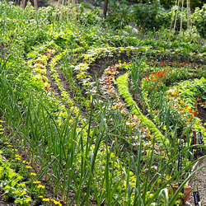
Register before 10.2.2020 $1250
Concessions available . Enquiries
Christo Miliotis growingbd@gmail.com +61488061077 www.groundsforhope.xyz

